Intro to Unreal Engine - Part Two
  - Animations and Checkpoints

Overview
This second module in our 5-part Intro to Unreal Engine introduces exciting new opportunities. Our overall game level challenges the player to navigate across a perilous void to unlock a door that holds the secrets of the future. In the previous activity, we built a parkour challenge to bring the player to a second large floating island. In this activity, we’re going to increase the difficulty by creating treacherous moving platforms leading to the next step. In addition to the added difficulty, we will introduce a reward in the form of a checkpoint. When the player reaches the checkpoint, they’ll respawn at that location, so they don’t have to restart.
This module contains screenshot from Unreal Engine 4. Although the look and feel of the UI has been updated for Unreal Engine 5, you should still be able to follow these screenshots while working through this tutorial. Please alert your instructor if you come across instructions or screenshots that need to be updated.

Learning Outcomes
By the end of this module, you should be able to:
- Set and use camera bookmarks to quickly navigate within your level.
- Place save check points within your level to aid the player as they progress.
- Use the level sequencer tool to animate the position of static meshes.
- Understand the purpose of Blueprint scripts in adding functionality to level assets.
🤝 PRO TIP FOR THE WIN
Camera bookmarks are useful for quickly changing your location in the editor. To see how they work, first click anywhere inside the Viewport, then press the number 1 or 2 at the top of your keyboard. You will notice that the camera will jump to specific locations.
1 = beginning location of activity 1
2 = beginning location of activity 2
This allows you to quickly move around your level without having to manually navigate from one place to another. Buttons 1–7 are assigned to important locations for this level. You can assign your own camera bookmarks by pressing the Ctrl + any number at the top of your keyboard. Try using numbers 8, 9 and 0.
Your Turn: Set another camera bookmark somewhere in the level using Ctrl + 8. To check if it worked, you can revisit other camera bookmarks by pressing a number between 1 and 7. Now press 8 on the keyboard and it should bring you to the bookmark you created. Did it work?
And don’t forget the “Play From Current Location” tip from part one!

Let’s Play
Checkpoints are used in games to reward players for completing difficult tasks. They also allow players to try a difficult sequence over and over without having to waste time travelling to it from the beginning of the level. Let’s add a checkpoint to reward the player for getting across the floating islands we added in Activity 1.
Press the number 2 on your keyboard to trigger the camera bookmark for the first checkpoint position. In the Content Browser navigate through the Hour_of_Code folder to the Blueprints folder and find the BP_checkpoint asset.
Drag one into your scene to the large floating island, before the second tunnel (Figure 001).
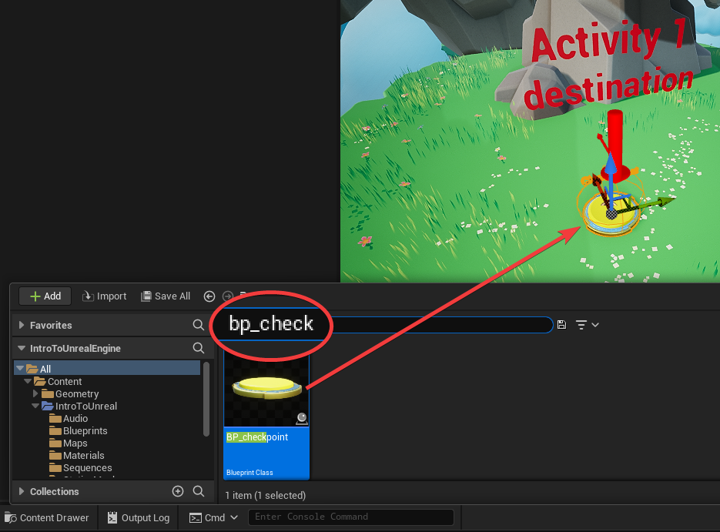
Figure 001 – Placing a Checkpoint
🤝 PRO TIP FOR THE WIN
When placing items on the ground:
- After placing the checkpoint in the world, press the W key to enable the Move Gizmo.
- Grab the blue arrow and drag the checkpoint up above the ground.
- Press the End key on the keyboard to snap the checkpoint down to the ground.
- Then press the E key to activate the Rotation Gizmo and click and drag on the blue curve to rotate the checkpoint so the red arrow is pointed in the direction you want your character to face when they respawn (Figure 002).
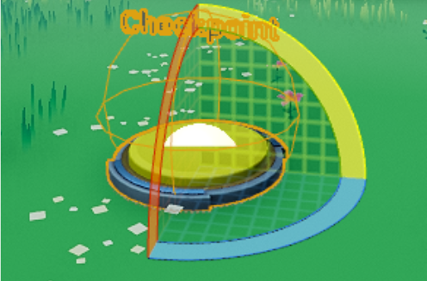
Figure 002 – Checkpoint With Rotate Gizmo
Position yourself above the platform near the checkpoint you just placed. Make sure you’ve selected the Current Camera Location from the Play button drop-down menu. Now play the game to test the checkpoint by walking over it. It should turn blue when it is activated. After activating the checkpoint, jump off the edge of the island. You will respawn at the checkpoint facing the direction the red arrow is pointing.
Checkpoint deployed! Follow these same steps to place a checkpoint at any part of the game.
📝 NOTA BENE
The checkpoint actor isn’t something that comes with Unreal Engine. It was created and scripted specifically for use with this project. Later in this activity we’ll explore the scripting that makes the checkpoint functionality possible.

Moving Platforms and Moving Islands
Back in the game, walk to the tunnel and ride the moving platform to the end of the tunnel. This introduces a new game mechanic, moving platforms! To create moving platforms, we are going to have to learn how to create an animation sequence in Unreal Engine. Hang on tight. We will get to that shortly! As you ride the moving platform that has been provided, you’ll arrive at the edge of the next void we want to cross. Having completed the previous activity, you’ll have some experience with placing floating islands in your world. Press 3 to move the camera to the endpoint for this module. This is where you want your character to arrive after traversing across the moving islands you are about to place in the scene and animate.
Locate the Static_Mesh folder in the Content Browser (Content > Hour_of_Code > Static_Meshes) and find the SM_FloatingIsland_S static mesh. You’ll add a few of them to get across the void to the next section, but let’s start by placing one in the void at the end of the tunnel. Drag the SM_FloatingIsland_S mesh into the world. With the newly placed floating island selected, press the W key to use the Move Gizmo. Click and drag the arrows to place the island in your desired position (Figure 003).
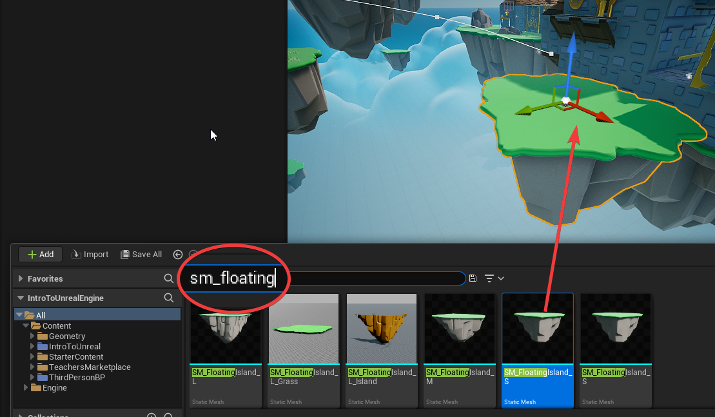
Figure 003 – Placing Another Floating Island
After placing the first island, we can save time by quickly duplicating the island to place any other islands needed to reach the next level. To duplicate the first island, make sure it is selected with the Move gizmo.
Remember that we can duplicate an Actor in the world by holding the ALT key and then clicking and dragging one of the Actor’s Move Widget arrows. You will need to let go of the Alt key once you have created a duplicate, then hold it again to create a new duplicate. Repeat this as needed so that you have enough islands. (Three floating islands should be sufficient.) Once you have enough islands in place, change their position and test your level to see if you can get across to the next large floating island.
Let’s make it a little more challenging this time by giving them a Looping animation, to make them move around. We will use a feature called Sequencer to create the animations.
In the Content Browser select the Content > Hour_of_Code > Sequences folder. Click the Add button (with the green plus symbol) in the top-left of the Content Browser and navigate to Cinematics, then choose Level Sequence (Figure 004).
This will create a new Level Sequence. Name it: S_movingPlatforms
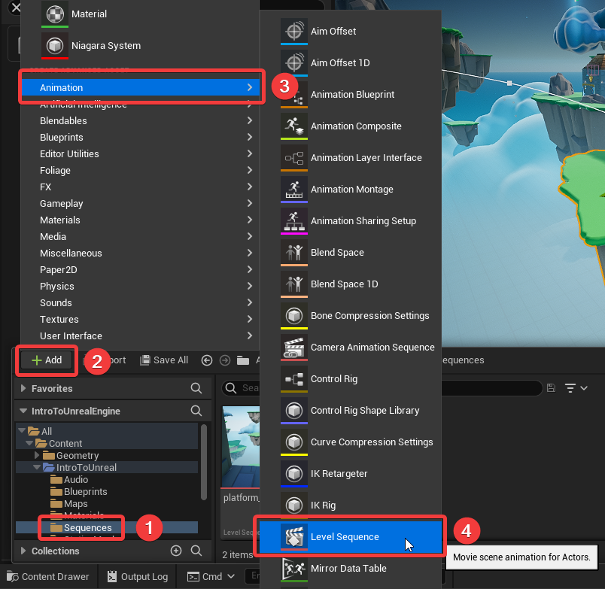
Figure 004 – Creating a New Level Sequence
Double click the S_movingPlatforms sequence to open Sequencer. (Figure 005)
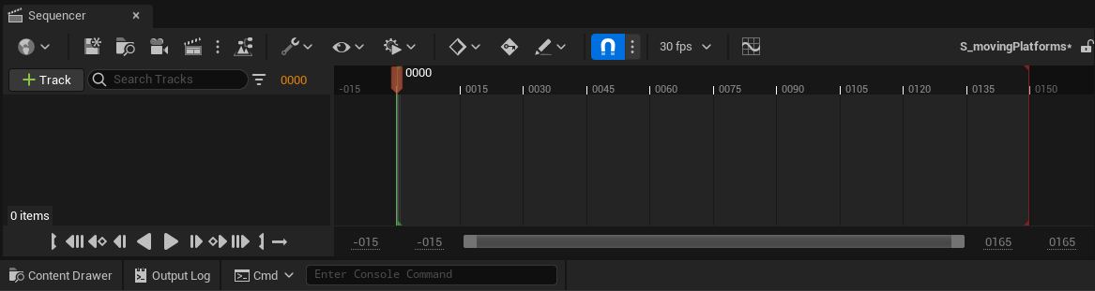
Figure 005 – The Sequencer panel placed next to the Content Browser panel.
Let’s take a moment to talk about animation. Animation is controlled by using a timeline to manipulate two attributes:
- Time
- Keyframes
We will use keyframes to tell a floating island where it needs to be, and at what time it should be there. There is also an order of operations to follow when creating keyframes that will help avoid issues. The order is:
- Set the Time by moving the playhead in the sequence timeline (time)
- Set the Location by moving the object to its target location for that time in the viewport (keyframes)
🤖 TECHNICAL JARGON DEFINED
Keyframes specify a snapshot of an object’s position, rotation, and scale at a particular time. Transition animations between keyframes can be automatically generated by the engine. If you start an animation with an object at position “0” and set the object to position “500” at 5 seconds, you would set keyframes at 0 and 5 seconds on the timeline.
Tweening (or In-betweening) is a term in computer animation to describe the auto-computed positions between two keyframes. Lerp (Linear Interpolation) is used to calculate the coordinates between two points using a straight line approach.
Let’s animate our floating islands. First, select all your floating islands, you can hold Shift while clicking on actors to add them to your selection. (You will see a gold outline on objects that are selected.) Then right-click in the empty gray area on left side of Sequencer (where it says RMB on Figure 006), chose Actor To Sequencer > Add Current Selection (# actors)
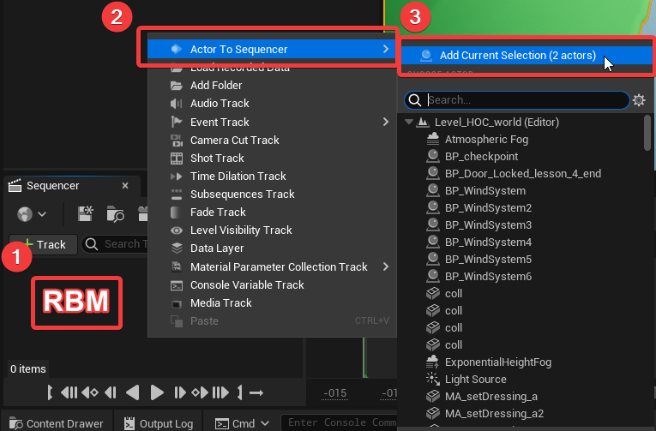
Figure 006 - Select all floating islands and right mouse click to add to the Sequencer
To make the animation process easier, click the key icon at the top of the Sequencer panel. This will toggle ON the auto keyframe function, which will create our keyframes automatically as we move our floating islands around in the level.
🤝 PRO TIP FOR THE WIN
Preventing glitchy loops. If you are designing an animation to loop, you will want to end the animation at the same position as the beginning. Looping an animation where a keyframe value starts at 0 and ends at 500 will cause a jump from 500 to 0 when the sequence loops back to the beginning. Adding an additional keyframe to transition the value from 500 back to 0 will create a smooth transition upon looping.
Ok, we’re now ready to animate our platforms using this 10-step process:
- Move the Playhead to around frame 15 in the timeline, and then select the first floating island (Figure 007). Remember, time first, location second.
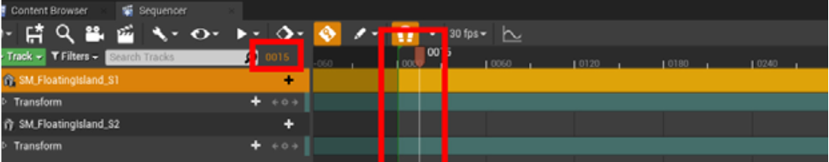
Figure 007 – Select the first floating island and move the playhead to 0015
- To create a Keyframe click the add keyframe button of the transform section of your selected floating island (Figure 008).
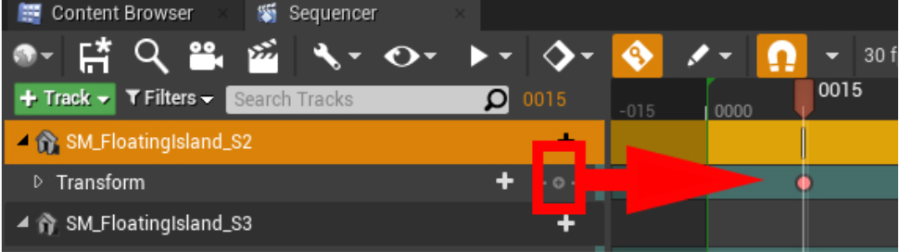
Figure 008 – Click the button for manually adding keyframes.
- Next, let’s change the time, then change the location of the first platform.
  - Set the playhead to frame 45 (Figure 009).
  - Move the floating island to another location by dragging the red Move Gizmo.
This step will move the platform from the starting position at 0015 on the timeline to the destination position set at 0045 on the timeline. The platform will move smoothly between the two points.
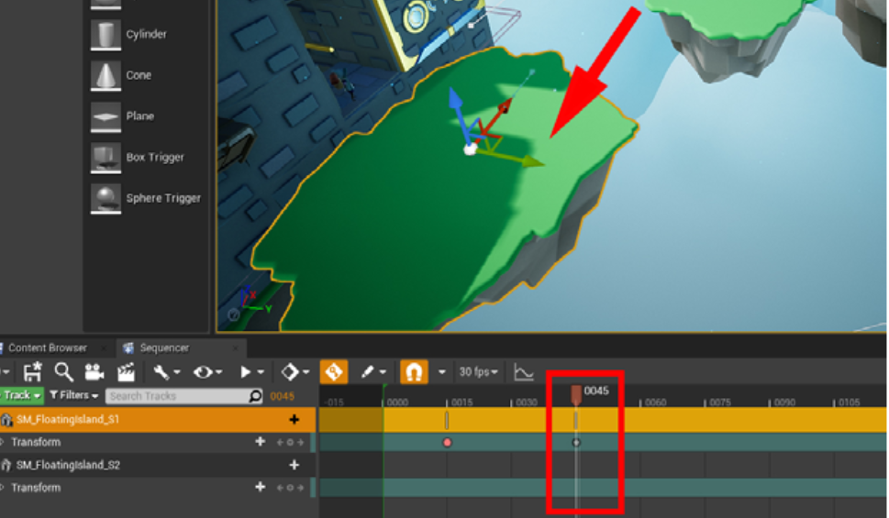
Figure 009 – Setting the next keyframe position at 0045
- We can have the platform remain stationary by setting another keyframe, but not moving the platform.
  - Move the playhead to frame 75.
  - Click the add keyframe button in the transform section (Figure 010).
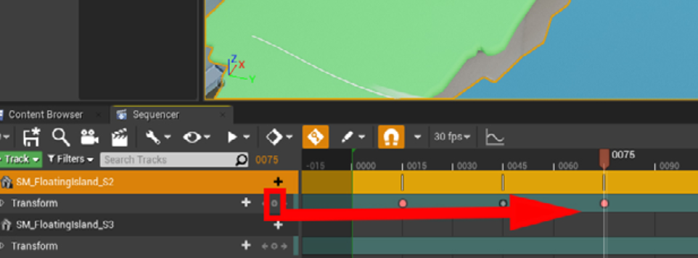
Figure 010 – Using a keyframe to hold an island stationary until 0075
- To complete the loop, we will need to copy the original location and paste it at the end of the animation. Select the first keyframe, right-click and choose Copy to save it to the clipboard.
- Next, move the play head to frame 105, right-click the sequence timeline, then choose Paste > Transform.Location (Figure 011) If you click and drag the playhead back and forth in the timeline, you will see your floating island move. You can also change the timing of the animation by moving the keyframes left and right in the timeline. 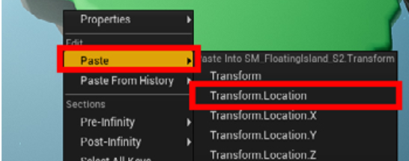
Figure 011 – Pasting a keyframe
- By default, the timeline has set the sequence duration to 150 frames; this can be shortened by dragging the red line to the right (Figure 012). Let’s shorten the animation to 120 frames.
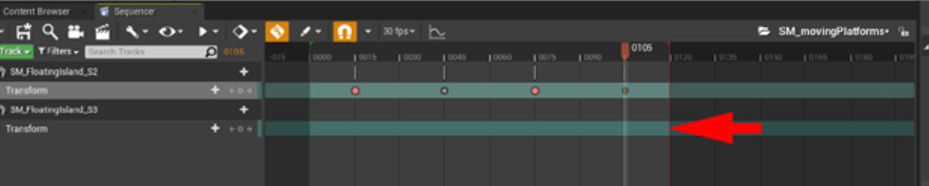
Figure 012 – Change the animation length by dragging the red line
- Be sure to Save your sequence animation by clicking the save icon in the Sequencer panel, or by choosing Save All from the File menu.
- Now you need to add the sequence to your level. If you don’t, the floating island won’t animate when you play the game. In the Content Browser drag the S_movingPlatform sequence into the level and place it near the animated floating island (Figure 013).
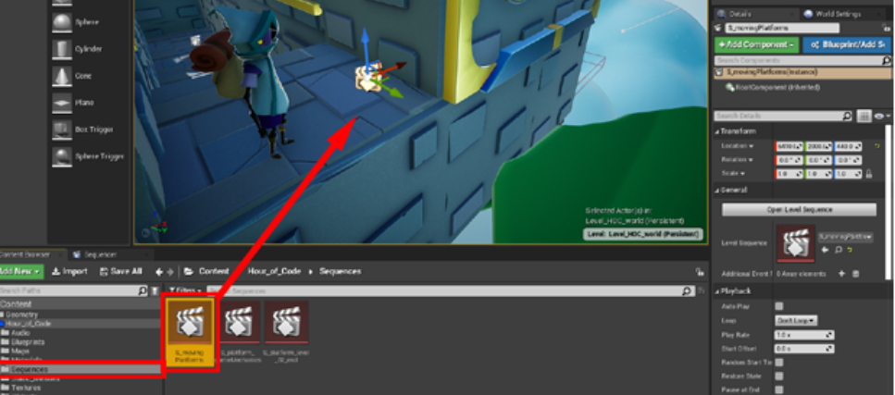
Figure 013 – Add the moving platform sequence to the world
- Now let’s set the animation to play automatically when the game starts, and also set it to Loop. By setting the animation to Loop, the animation will repeat as soon as it completes.
  - Select the S_movingPlatform actor in the level.
  - In the Details panel, toggle Auto Play ON.
  - Open the Loop drop-down menu and choose Loop Indefinitely (Figure 014).
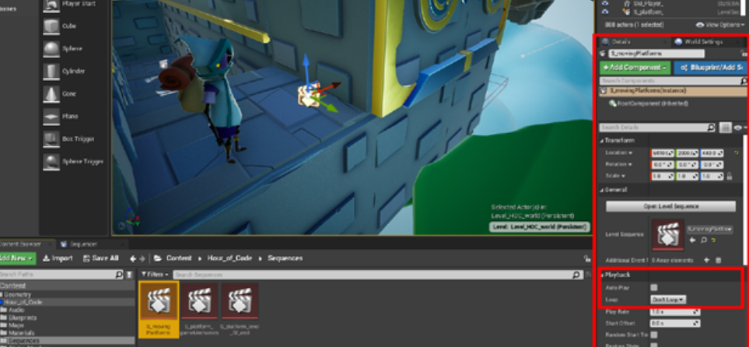
Figure 014 – Set the looping attribute of the moving platform.
It’s time to play-test. Play your level and see how the animation you just created moves the platform around in your level.

Animate the Remaining Islands
Now that you understand how to animate objects using Sequencer, you can animate the rest of your floating islands. We have already added the other islands to the sequence, so you will only need to keyframe them.
🖖 LENDING A HELPFUL HAND
Remember: When setting a keyframe, it’s position first, then time. Also, save early, save often, save all.
Give your players enough time to jump from one platform to the next, one second is usually enough, though this will depend on the player. Getting feedback will help ensure your game is enjoyable. The default setting in Unreal is 30 frames per second. So, keep the platform stationary for at least 30 frames.

Add Another Checkpoint
To complete this activity, add one more checkpoint to reward your players when they make it across all your moving islands. Drag another BP_checkpoint to the large floating island destination and rotate it to face the next floating island (Figure 015).
Remember to Save All your work.
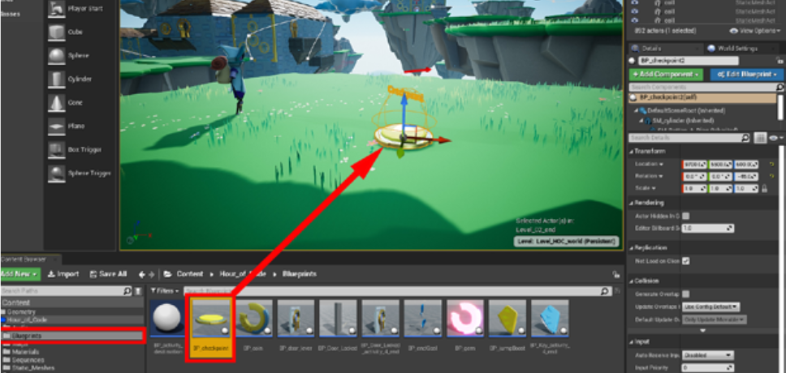
Figure 015 – Add another checkpoint at the end of the moving platform.
🤝 PRO TIP FOR THE WIN
Naming conventions in Unreal: You may have noticed that there are specific conventions used when naming assets in Unreal. In this project we’ve seen:
Static Mesh Assets Start With: SM_
Blueprint Assets Start With: BP_
Sequence Animations Start With: S_
Different studios use different naming conventions. A popular open-source convention and style guide can be seen here: http://ue5.style/ (Note that our conventions differ from this guide for static mesh and sequence animations!)

Coding in Unreal Engine with Blueprints Visual Scripting
Unreal Engine is an incredibly powerful platform used to build games, movies, digital product presentations, virtual reality environments, and more. Despite having such extensive technical features, it is possible to create content without writing code. This is made possible by a drag and drop visual editing process known as Blueprints. We’ll dive into a pre-built Blueprint in this activity, and future activities will explore modifying them for our project.
Let’s take a minute to look under the hood of what is happening inside the BP_checkpoint actor. In the Content Browser, double click the checkpoint actor to open the Blueprint Editor. Here you can see it has been broken up into 5 different chunks of code (Figure 016).
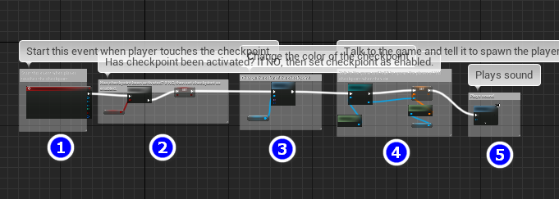
Figure 016 – A Zoomed Out View of the Checkpoint Code. (Excuse the unreadable comments.)
By looking at each section closely we can get an understanding of what this blueprint is doing. In simple terms, this blueprint spawns the character at its location after the character dies. But that only scratches the surface.
Section 1:
- When the player crosses the collision sphere, the blueprint activates the EventBeginOverlap node which starts the chain of events. Visit the “Viewport” tab to see the checkpoints Sphere_coll collision component.
Section 2:
- Next, the code checks to see if this checkpoint has been activated before.
  - IF it has (true), the code stops and nothing else happens.
  - IF not, then it sets a variable to True.
  - A True/False variable is called a Boolean, Bool for short.
Section 3:
- At this stage the code changes the color of the material on the cylinder to blue. This is so the player knows they have already walked over this checkpoint. This is known as a “quality of life” feature, making it easier for players to understand what has happened in their game at a glance.
- The Dynamic MI Ref is a reference to the material being used by the cylinder.
- When this node is reached, the “Color” parameter is assigned the value blue.

Section 4:
- This section is making “a call” to the game mode, which is where the overarching logic and rules for a game are defined.
- Think of it like this:
  - This checkpoint is an actor in your level, and it needs to tell the game mode that the character just walked through it.
  - To do this, it needs to make “a call”, and it make this call it must do what is called Casting in code language.
  - Casting allows the code to communicate with other Blueprint scriptable entities.
- So, this fourth section is telling the game mode that the character just walked over the checkpoint.
- The game mode is storing the checkpoint’s current location/rotation information (its transform) using a Set operation on the game mode’s Spawn Location variable.
- The game will use that stored information to spawn the character back at this location when/if the player dies.
Section 5:
- This last section plays a “checkpoint activated” sound.
- The sound file being played is selected from a drop-down list of all the audio files in the project.

Play Testing
Now that your moving platform route is complete you should play test your level by getting two other people to attempt your route. Watch your play testers play the level, but don’t tell them where to go. Observe where they get frustrated or where they get lost. Use these observations to improve your platform sequences to make the journey more fun.

Part Two Completed!
Well done! You’ve added sequence animations to your level designed toolkit. You’ve also gotten a peek at how actors can be scripted using Blueprints visual scripting. Don’t worry if the Blueprint coding felt confusing, we’ll walk you through creating your own Blueprints scripts in later modules.

What’s Next?
In the next activity we will introduce new game elements in the form of collectible items. We’ll also add challenges that require the player to unlock special powers. These powers will allow your players to reach new locations they couldn’t before. Collectible coins will entice the player to venture into uncharted territory.
🚀 YOUR PROGRESS
   

Further Reading
- Official Unreal Sequencer Overview
- Official Viewport Options Guide

